**FEDRAL BOARD OF INTERMEDIATE AND SECONDRY EDUCATION ISLAMABAD**

ISO 9001: 2015 CEERTIFIED

MIGRATION CERTIFICATE (NOC)

CANDIDATE NAME okok DOB 30/03/1974

_________________________ ____________

FATHER’S NAME javed

_______________________________________________

REGISTRATION NO 887767898 Roll no. 1099

_______________ ____________

EXAMINATION Fedral board SESSION Final Session

____________ ____________

YEAR 1019 STATUS(P/F) pass

______ ____________

INSTITUTION Fedral board Islamabad

_________________________________________________________

_________________________________________________________

The candidate is permitted to migrate from the jurisdiction of the Board for studies or

Appeared in any examination from another Board / University, otherwise eligible

Islamabad Dated 12/12/12 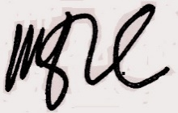

CONTROLLER OF EXAMINATION